SYSTEM FUNCTIONAL SPECIFICATION DOCUMENT

Global Tobacco Connect

|  |  |
| --- | --- |
| **Project Code** |  |
| **Project Name** | Global Tobacco Connect |

|  |  |  |
| --- | --- | --- |
| **Prepared/Modified by** | **Role** | **Date of Preparation** |
| Prashant Kore | GTC Business Analyst | 05-19-2017 |
| **Reviewed by** | **Role** | **Date of Review** |
|  |  |  |
| **Approved by** | **Role** | **Date of Approval** |
|  |  |  |
| **Circulation List** |  | **Template version: 1.2** |
| **Version Number** | 1.0 |  |

Table of Contents

1. Introduction 4

1.1 Purpose 4

1.2 References 4

2. Project Scope 6

2.1 Scope / System Functionality 6

2.1.1 Login 6

2.1.2 Registration 6

2.1.3 Forgot Username 6

2.1.4 Forgot Password 6

2.1.5 DB Opt Off 7

2.1.6 Email Platform 7

2.1.7 Edit Profile 7

2.1.8 Inline Edit 7

2.1.9 Footer Links 8

2.2 Out Of Scope 8

2.3 Assumptions 8

2.4 Dependencies 9

3. UI Requirements 10

4. New Requirements 11

4.1 Login 11

4.2 Login Interrupts 11

4.3 Registration 12

4.3.1 Remove the Tobacco Usage Questions from the “Verify Information” page and move it to the “Create Profile” Page 12

4.3.2 Remove the “Email Address” field from the “Create Profile Page” 12

4.3.3 Discovery and Ever Occupancy related changes are incorporated in to new Registration flow and functional details are mentioned in the SSN4 Additional Address Usecase specifications document. 15

4.3.4 LexId changes: If the Lex Id is not returned with the New User Details and consumer not found with SFNA – Full search (status code:1363), then single Additional Address screen needs to be shown as discovery is failed with SFNA. 15

4.3.5 If the the Lex Id is not returned with the New User Details and consumer is found with SFNA – Full search but house hold limit exceeds or opted off or DOB does not match (status code:1364), then New Registration flow should show error message screen with API message. 15

4.4 Unsubscribe 15

4.5 Edit Profile 15

4.5.1 User can participate in survey on n number of times whereas existing site allows only once 15

4.5.2 In the existing functionality For Marlboro Additional question comes in the survey without considering the user’s brand choice. We have changed that logic that If user select the competitor brand then  only additional question will come. 15

4.5.3 SubMenu will not available in Edit Profile Page as per requirement with Back button user can redirect to branded websites.Existing Marlboro website doesn’t have this functionality 15

4.5.4 Edit Profile Survey Question UI Requirements 17

4.6 Update Double Opt In 20

5. Strategy 21

5.1 Implementation & Supporting Information 21

6. System Interfaces 22

6.1 Software Interfaces 22

7. Appendix B: Glossary 23

REVISION HISTORY OF THE WORK PRODUCT 24

# Introduction

This document contains current system functionality and scope of the Global Tobacco Connect. Any changes to scope must be approved via a Change Request.

## Purpose

The Global Tobacco Connect platform performs numerous services for the branded websites, with the main purpose of the platform allowing for the login and registration of the ATC21+ to use the branded site.

However, Global Connect also performs several utility services for the ATC21+. Forgot Username and Password allows ATC21+ to retrieve or reset their authentication credentials, whereas Database Opt Off allows an ATC21+ to remove themselves from email, direct mail (and by proxy, SMS communications), regardless of whether or not they have a branded web profile. Finally, the ATC21+ has the ability to view items tied to the brand via the Footer as well as through Emergency Messaging.

Below are the list of the services that G-Connect performs:

|  |  |
| --- | --- |
| Description | |
| Login (Standard) | UI Flow Augmentation Rules (Login Interupt Scenarios) |
| Forgot User Name | Signup by Name and Address |
| Forgot Password | DB OPT OFF |
| PIN Login | Signup by CCN |
| Create PIN | Unsubscribe |
| Forgot PIN | Double OPT-IN |
| Register PIN | Edit Profile |
| Inline Edit | Footer Links |

## References

Below are the list of the Functional / Technical requirement documents of the existing G-Connect system developed by LBD.

|  |  |  |  |
| --- | --- | --- | --- |
| Document Name | Type | Description | Version |
| 16.2.0 - Global Connect - Login Business Requirements Document V2.01.docx | Business Requirements | This document contains business requirements for the Login Functionality of Global Connect | v2.01 |
| Gconnect Login TUC v3.02.docx | Technical Use Cases | This document contains the technical Use Cases associated with Global Connect Login functionality on the site. | v3.02 |
| 16.2.0 - Global Connect - Registration Business Requirements Document.docx | Business Requirements | This document contains business requirements for the Registration Functionality of Global Connect. | v1.00 |
| Gconnect Registration TUC v1 01.docx | Technical Use Cases | This document contains the technical Use Cases associated with Global Connect Registration functionality on the site. | v1.01 |
| 16.2.0 - Email Platform - Unsubscribe Business Requirements Document.docx | Business Requirements | This document contains business requirements for the Unsubscribe Functionality of Global Connect. | v1.00 |
| Email Platform Unsubscribe TUC v3.01.docx | Technical Use Cases | This document contains the technical Use Cases associated with Global Connect Unsubscribe functionality on the site. | v3.01 |
| 16.2.0 - Email Platform - Double Opt In Business Requirements Document.docx | Business Requirements | This document contains business requirements for the Double Opt In Functionality of Global Connect. | v1.00 |
| Email Platform Double Opt In TUC v3.02.docx | Technical Use Cases | This document contains the technical Use Cases associated with Global Connect Double Opt In functionality on the site. | v3.02 |

# Project Scope

## Scope / System Functionality

## Login

***Standard Login Process***

As part of Login functionality, Global Connect allows any ATC21+ with a valid, active web profile (provided they are Available, Qualified and Contactable) to access the branded site, using the following methods:

* Login with Email / Username, Password and Date of Birth
* Login with 5 digit PIN

Following diagram shows standard Login process flow.

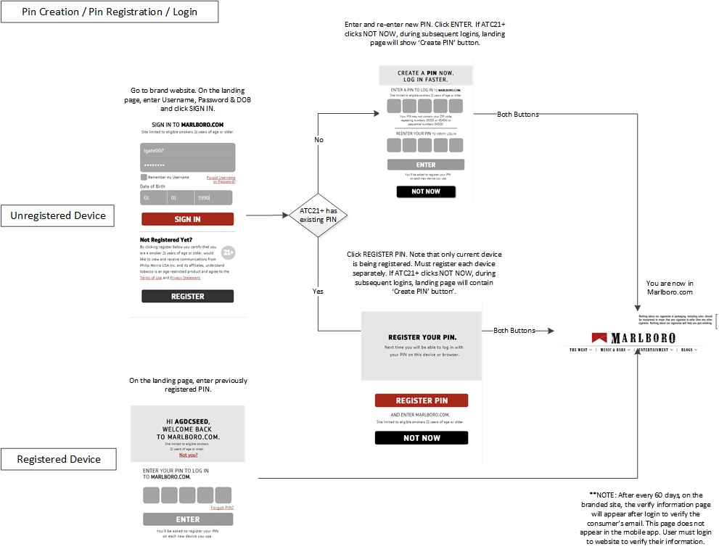

* **Login with Email / Username, Password and Date of Birth**
  + Navigate to brand website. On the landing page, enter Email / Username, Password & DOB and click “SIGN IN”.
  + System validates submitted credentials and upon successful validation, if ATC21+ has 5 digit PIN,

Then system displays “REGISTER YOUR PIN” screen to allow ATC21+ to register 5 digit PIN to current browser. (*NOTE: if ATC21+ clears browser cache and cookies, then ATC21+ has to re-register 5 digit PIN)

Else

“CREATE A PIN NOW” screen is displayed. ATC21+ may create a 5 digit PIN that satisfies predefined rules mentioned in below section.

* + ATC21+ may skip step of creating or registering 5 digit PIN by clicking “NOT NOW” button. During subsequent logins, landing page shows “Create PIN” button.
  + System displays brand website homepage after creating or registering 5 digit PIN or skiping the above step.
* **Login with 5 digit PIN**
  + Navigate to brand website. System displays welcome screen with first name of ATC21+. Enter 5 digit registered PIN and click “ENTER”.
  + System displays brand website homepage after successfully validating 5 digit PIN.
  + ATC21+ may bypass “Login with 5 digit PIN” process by choosing either “Not you?” or “Forgot PIN?” options.
  + If ATC21+ clicks on “Forgot Pin?” link, then system displays “RESET YOUR PIN” screen to allow ATC21+ to choose new 5 digit PIN. If ATC21+ clicks on “Not you?” link, then system displays brand login page.

Following are the field and page layout specific business rules and key functionalities that are present as part of the Login process.

1. On Login screen, cursor is focused on the first field “Email or Username”.
2. “Forgot Username or Password?” link to reset Username or Password is available in red text and is right aligned under “Password” field and the “Password” field spans the full space similar to “Email or Username” field.
3. “Remember my Username” checkbox is unchecked and left aligned under “Password” field.
4. Valid Year of Birth is 1900 and onwards.
5. “CREATE PIN” button is only displayed if user has previously logged in and not yet registered the PIN with browser. This button is not displayed for new browsers.
6. 5 digit PIN may not contain ATC21+’s ZIP Code, Repeating Numbers / Number Patterns (e.g. 33333 or 45454) or Sequential Numbers (e.g. 54321). Also, “ENTER” button on “CREATE A PIN NOW” screen is only enabled when ENTER A PIN and REENTER YOUR PIN fields are populated.
7. System doesn’t allow ATC21+ to login with existing PIN if it is registered for more than 90 days.
8. “Sign In” and / or “Create Pin” and “Register” sections are separated by a dotted line.
9. Certification text is available on Login screen above “REGISTER” button.

***Login Lockout Process (Multiple Incorrect Password / PIN Login Attempts)***

* In case of 5 unsuccessful login attempts using either of the above two mentioned ways, ATC21+’s account is locked and must wait for 15 minutes to attempt log-in or call the call center to reset Password.
* Once the window of first 15 minutes is complete, only 2 unsuccessful login attempts are allowed before ATC21+’s account is again locked.

Following diagram shows Login Lockout process flow.

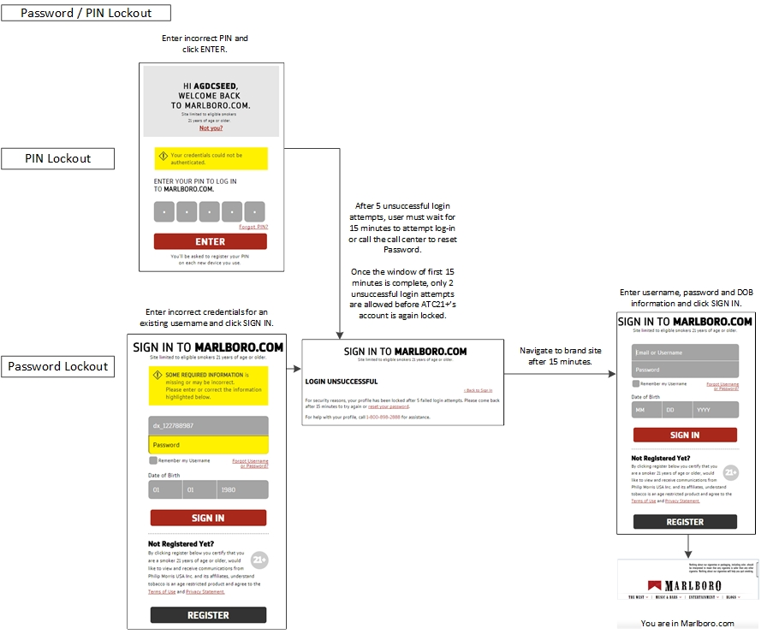

Following are the error messages that system displays in case of any exceptions.

|  |  |  |
| --- | --- | --- |
| **No.** | **Error Condition** | **Error Message** |
| 1 | Missing / Invalid Fields | SOME REQUIRED INFORMATION is missing or may be incorrect. Please enter or correct the information highlighted below. |
| 2 | Missing Username | Please enter your Login ID |
| 3 | Missing DOB | Please enter your date of birth in this format: mm/dd/yyyy |
| 4 | Invalid Username | The Login ID that you entered was not found. Please re-enter your Login ID. |
| 5 | Invalid 5 digit PIN | Your credentials could not be authenticated. |
| 6 | Permanent OptOff at Consumer Level | We're sorry, we are unable to process your information at this time. |
| 7 | Login Lockout | LOGIN UNSUCCESSFUL  For security reasons, your profile has been locked after 5 failed login attempts. Please come back after 15 minutes to try again or reset your password. For help with your profile, call <Customer Care Number> for assistance. |

As part of Login process, the ATC21+ may get interrupted to perform the following updates:

* **Update Temporary Password**
  + ATC21+ is prompted to update Temporary Password if system determines that ATC21+ has a Temporary Password and ATC21+ is signing in to the Global Connect with Email / Username, Password and Date of Birth.
  + Update Temporary Password screen is not displayed if ATC21+ signs in to Global Connect with 5 digit PIN even when ATC21+ has a Temporary Password.

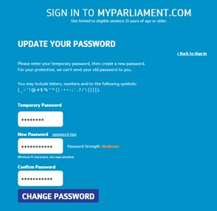

* **Update Security Question**
  + System asks ATC21+ to update security question if
    1. No security question is on file for ATC21+ web profile
    2. Security question is not considered as Active by the ATCD

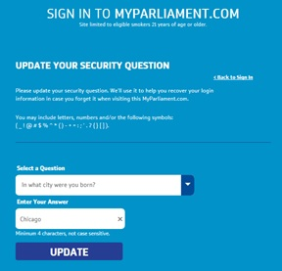

* **Update Email Address**
  + System interrupts ATC21+ having contactable, subscribed, pending DOI email after pre-defined period of time (15 days for all brands) to complete their email registration with following message.

*Recently you signed up to receive email regarding special offers from <<Brand Name>>. Before you can receive this information, you'll need to request a confirmation email.*

* + ATC21+ has ability to modify the earlier provided email address.
  + System shows following messages when ATC21+ tries to request a confirmation email depending on whether a confirmation email has been sent to ATC21+ or not.

If confirmation email is already sent,

*Please check your email inbox. An email has already been sent to you.*

Else

*An email from <<Brand Name>> will be arriving in your inbox shortly. Click the confirmation link in that email to complete your email registration.*

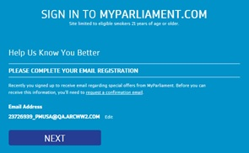

* + System also interrupts ATC21+ having non contactable email address on file to update their email address with message *SORRY, WE CAN'T DELIVER TO THIS EMAIL ADDRESS*.

NOTE: After every 30 days, the Verify Information interrupt appears after login to verify the email address of ATC21+.

* **Update Tobacco Usage Questions**
  + System interrupts ATC21+ to choose tobacco products that they use and answer product related questions if ATC21+ has not answered tobacco product questions for the brand or their tobacco product questions and answers are out of date (based on pre-defined period: 180 days for ‘Black & Mild’ and 120 days for all other brands).
  + Tobacco Usage section is displayed with 4 options which can be checked.
    1. Cigarettes
    2. Snus
    3. Dip
    4. Cigars

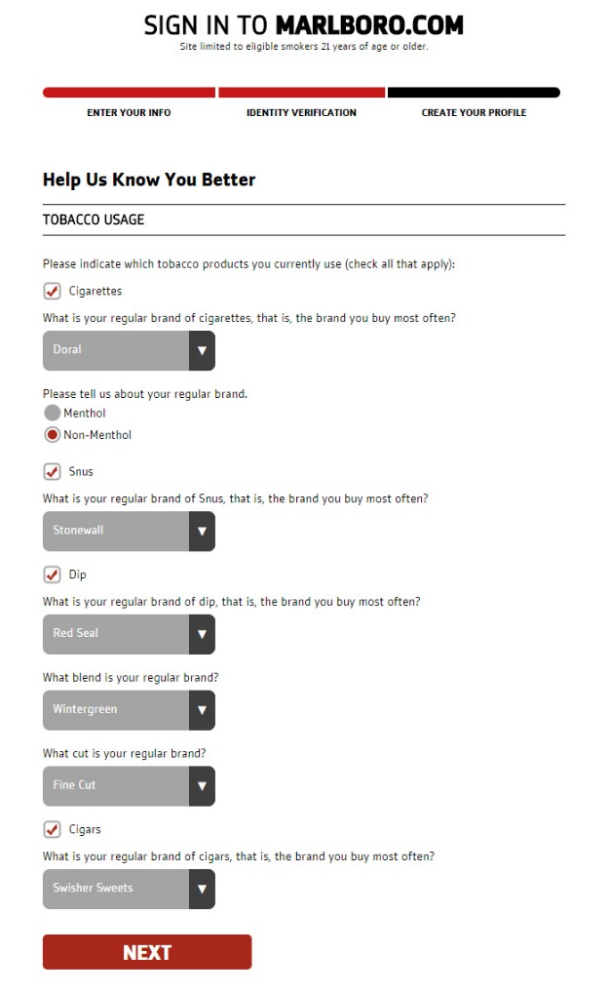

* **Re-Certify (for the purposes of reversing any reversible Opt Offs)**
  + System interrupts ATC21+ if ATC21+ is not certified to receive tobacco communications on behalf of the brand.
* **Create or Register a 5 digit PIN**

The order of these interrupts is as follows:

Verify Information (Email Address, Tobacco Usage Question, Opt Offs) 🡪 Update Temporary Password 🡪 Update Security Question

## Registration

As part of Registration functionality, Global Connect allows any ATC21+ to create a web profile to access the branded site, using the following methods:

* Register with CCN and Date of Birth
* Register with Name, Address and Date of Birth

Before creating the web profile, the ATC21+ may be interrupted to help verify their identity via the following:

* Provide an additional address
* Provide last 4 digits of SSN
* Certify (for the purposes of new registration to the OpCo or to reverse applicable OptOffs)
* Take a Smart Quiz

The ATC21+ also has the option to add or update an email address during the registration process.

Following diagram shows Global Connect Registration process flow.

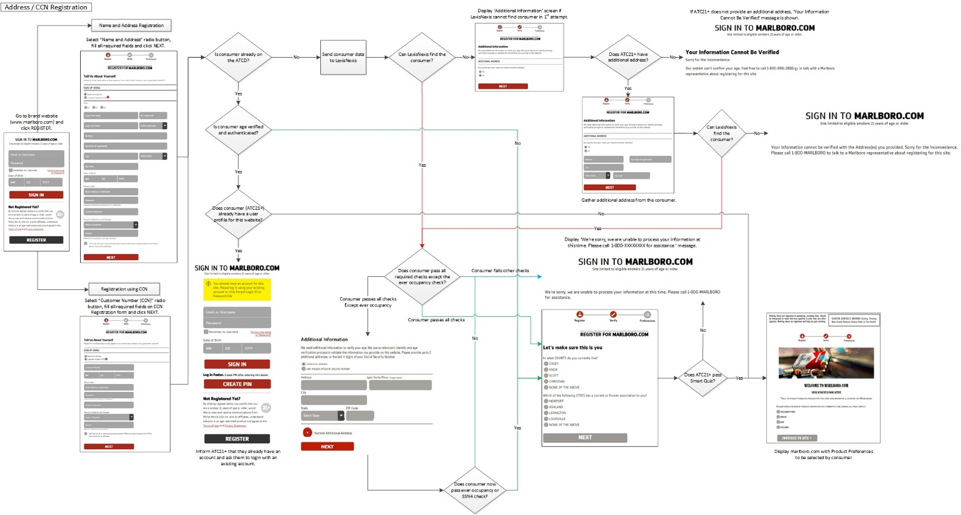

Following table lists the Required / Optional fields per registration method.

|  |  |  |  |  |
| --- | --- | --- | --- | --- |
| **Register with Name, Address and Date of Birth** | |  | **Register with CCN and Date of Birth** | |
| **Field Name** | **Required / Optional** |  | **Field Name** | **Required / Optional** |
| Title | Required |  | CCN | Required |
| First Name | Required |  | Date of Birth | Required |
| Middle Initial | Optional |  |  |  |
| Last Name | Required |  |  |  |
| Suffix | Optional |  |  |  |
| Street Address | Required |  |  |  |
| Apartment | Optional |  |  |  |
| City | Required |  |  |  |
| State | Required |  |  |  |
| Zip Code | Required |  |  |  |
| Date of Birth | Required |  |  |  |
| Email Address | Required |  |  |  |
| Password | Required |  |  |  |

* Global Connect tries to locate ATC21+ upon successful validation of provided information and completes the Registration process as per below mentioned steps.
  + Global Connect checks whether ATC21+ is present in ATCD or not.
  + **If (ATC21+ is present in ATCD)**

Global Connect checks whether ATC21+ is age verified and authenticated or not

**If (ATC21+ is age verified)**

Global Connect checks whether ATC21+ has user profile for branded website or not

**If (ATC21+ has user profile)**

Global Connect prompts ATC21+ to login using existing credentials

**Else**

Global Connect completes Registration process and navigates ATC21+ to branded website to submit Product Preferences

**Else**

Global Connect asks ATC21+ to answer Smart Quiz

**If (ATC21+ passes Smart Quiz)**

Global Connect completes Registration process and navigates ATC21+ to branded website to submit Product Preferences

**Else**

Global Connect displays error message

**Else**

Global Connect sends ATC21+’s information to LexisNexis and checks whether LexisNexis can find ATC21+ in their database or not

**If (LexisNexis finds ATC21+)**

----------------------------------------- Section A Starts Here ---------------------------------------

Global Connect checks whether ATC21+ passes all required criterias except ‘Ever Occupancy’ criteria

* **If (ATC21+ passes all criterias except ‘Ever Occupancy’)**

Global Connect requests additional address or last 4 digits of SSN to ATC21+

**If (ATC21+ passes ‘Ever Occupancy’ or SSN criteria)**

Global Connect asks ATC21+ to answer Smart Quiz

**If (ATC21+ passes Smart Quiz)**

Global Connect completes Registration process and navigates ATC21+ to branded website to submit Product Preferences

**Else**

Global Connect displays error message

**Else**

Global Connect displays error message

* **If (ATC21+ passes all criterias)**

Global Connect asks ATC21+ to answer Smart Quiz

**If (ATC21+ passes Smart Quiz)**

Global Connect completes Registration process and navigates ATC21+ to branded website to submit Product Preferences

**Else**

Global Connect displays error message

* **If (ATC21+ fails other criterias)**

Global Connect displays error message

----------------------------------------- Section A Ends Here ----------------------------------------

**Else**

Global Connect requests additional address to ATC21+

**If (ATC21+ provides additional address and LexisNexis finds ATC21+)**

Follow Section A

**Else**

Global Connect displays error message

## Forgot Username

As part of Forgot Username functionality, the ATC21+ is able to retrieve their username by supplying personal information:

* Retrieve Username with CCN & Date of Birth

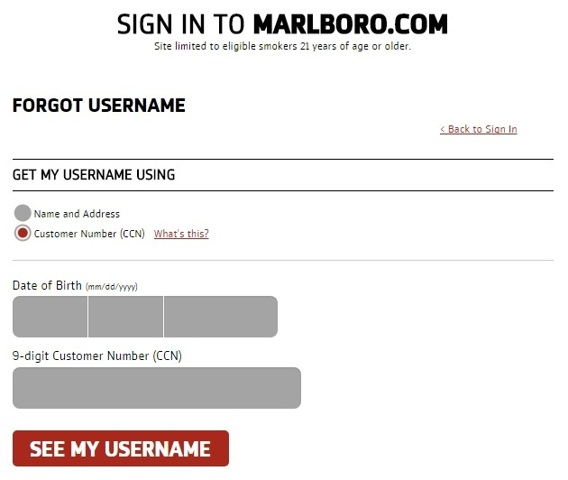

* Retrieve Username with Name, Address and Date of Birth

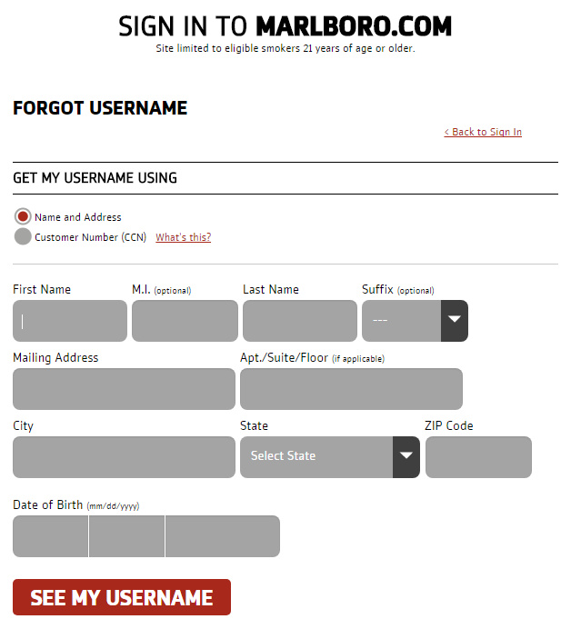

Following are the error messages that system displays in case of any exceptions.

|  |  |  |
| --- | --- | --- |
| **No.** | **Error Condition** | **Error Message** |
| 1 | Missing / Invalid Fields | SOME REQUIRED INFORMATION is missing or may be incorrect. Please enter or correct the information highlighted below.  On mouse hover on invalid fields: The information you provided does not match our records. Please verify your information and try again. |
| 2 | Missing First Name | Enter full first name with no punctuation. |
| 3 | Missing Last Name | Please enter full last name. |
| 4 | Missing Mailing Address | Please enter your street address. |
| 5 | Missing City | Please enter your city. |
| 6 | Missing State | Please enter your state. |
| 7 | Missing Zip Code | Please enter your 5-digit ZIP Code. |
| 8 | Missing DOB | Please enter your date of birth in this format: mm/dd/yyyy |
| 9 | Missing CCN | Please enter your 9-digit Customer Number. |

## Forgot Password

As part of Forgot Password functionality, the ATC21+ is able to reset their password by supplying profile information:

* ATC21+ kicks off the reset password process by supplying their username
* ATC21+ verifies that they own the account by answering their security question
* ATC21+ then supplies their new password

Following are the error messages that system displays in case of any exceptions.

|  |  |  |
| --- | --- | --- |
| **No.** | **Error Condition** | **Error Message** |
| 1 | Missing / Invalid Fields | SOME REQUIRED INFORMATION is missing or may be incorrect. Please enter or correct the information highlighted below. |
| 2 | Invalid Username | The Login ID that you entered was not found. Please re-enter your Login ID. |
| 3 | Invalid Security Answer | The Security Answer you provided does not match our records. Please re-enter your Security Answer. |
| 4 | New and Confirm Password Mismatch | Password' must match 'Password' above. |

Following diagram collectively shows Retrieve Username and Reset Password process flows.

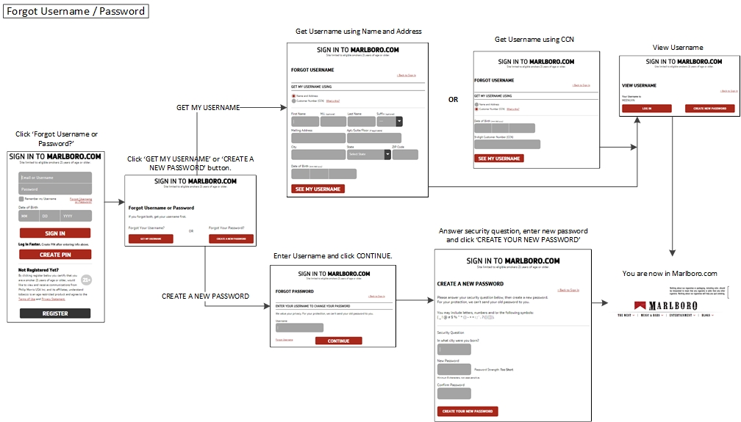

## Database Opt Off

As part of Database Opt Off functionality, the ATC21+ is able to remove themselves from Tobacco Communications tied to:

* The Brand(s)
* The Operating Company (which will subsequently opt them off of all brands that belong to the Operating Company)

To complete the process of Opt Off, ATC21+ needs to provide either of the following information.

* CCN and Date of Birth
* Name, Address and Date of Birth

If ATC21+ provides correct information,

System displays ‘YOU HAVE BEEN REMOVED FROM OUR MAILING LIST’ page with below message:

*You have been removed from the [OpCo] brand mailing list. Please note that you may still receive mailings that were already in progress for 10-12 weeks.*

*Please accept our apologies if you receive additional mailings during this time.*

*If you have questions about your removal from our mailing list, please call us at <Customer Care Number>.*

Else

System displays ‘WE’RE SORRY’ page with below message:

*The information you provided does not match our records. Please verify your information and try again.*

Following diagram shows DB Opt Off process flow.

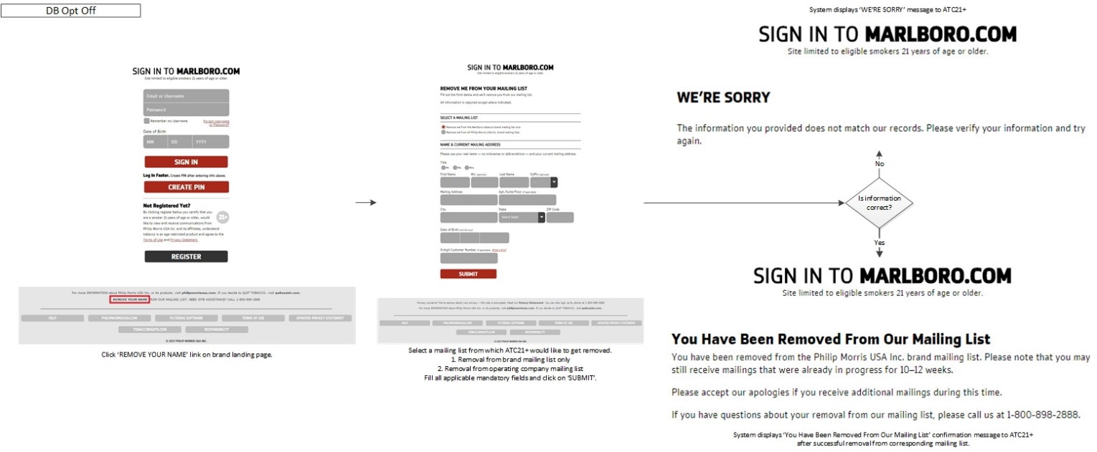

## Email Platform

The Email Platform allows an ATC21+ to manage both the Completion of the Double Opt-in process, as well as manage their existing subscriptions at an Operating Company, Brand and Promotional level

As part of Unsubscribe, the email platform will allow an ATC21+ with active email subscriptions to unsubscribe from the following tiers of emails:

* Operating Company tied to the Brand
* Branded emails
* Promotional emails

As part of Double Opt-In completion, the email platform will allow an AQC ATC21+ with a contactable OpCo/Brand subscribed email double-opt in, allowing them to receive fully branded email communications, as well as sign up for reminders via the branded websites.

Before completing their Double Opt-In, the ATC21+ may be interrupted to help verify their identity via the following:

* Provide their last name and date of birth (if email add/update was over 90 days ago)
* Take a Smart Quiz (if not currently authenticated on the ATCD)

## Edit Profile

As part of Edit Profile, the ATC 21+ is  able to update Email address, mailing address, password, pin, security question, smoking preferences.

* Branded website will be redirected to Edit profile page
* In Edit My Pack section, user can select his favorite brands
* User can take his Survey using survey questions section
* User can take his survey n number of times

## Inline Edit

            As part of inline edits ATC 21+ is  able to update his/her mailing address, email

* branded websites request the GTC for the inline form.
* GTC will send the inline form along with the short live token.
* User can update her/his mailing address/email address  by entering the data.
* Branded sites calls the GTC update mailing/email address API along with user entered data and short live token
* GTC validates the short live token update the data and sends back the status code, status message, short live token back to branded sites

## Footer Links

Finally, as part of viewing information to the Brand, the ATC21+ shall have access to the information via footer links or emergency messaging

* The ATC21+ will have access to FAQs
* The ATC21+ will have access to Filter Software Options
* The ATC21+ will have access to the Terms of Use
* The ATC21+ will have access to the Privacy Statement
* The ATC21+ will have the ability to visit QuitAssist, Operating Company’s website and Tobacco Rights
* The ATC21+ will have access to Responsibility policies
* The ATC21+ will have access to Emergency Information

## Out Of Scope

The new GTC platform will be developed as a stand alone component. Integration with the branded websites or any third party retailer apps is not included in the current scope of the work.

Once the platform is ready, there shall be a plan laid out to integrate with the branded websites in the sequence decided by the ALCS.

Listing the differences in the current GTC functionality for each brand website, if any.

Build you Brand section is currently out of scope.

## Assumptions

* The current GTC platform works exactly same for all the branded websites
* The new GTC platform would be built of the top of ATC API
* All the business logic of authentication, Signup and their related conditions are handled inside the ATC API. The new GTC platform functionality mostly would be limited to handling off the UI
* ATC API consumer messages will be displayed as part of any error messages on screen
* For all Password textboxes, there would not be any tooltip
* Allow only numbers to Date of Birth textboxes

## Dependencies

* The new GTC platform is dependent on the ATC API, if there is any new service that GTC needs to perform then there must be an API that supports the same feature.  
  

# UI Requirements

The phase 1 of the new GTC platform has to be built exactly like the current GTC. Hence all the prototypes that were used to build the existing system by the LBD team has been considered as the base UI. Different skins/themes would be applied based on the request that is coming to the new GTC.

Below is the zip file that contains the Axure Protypes of the existing GTC:



Some changes that were taken as a part of the new GTC is mentioned in section 4.

# New Requirements

## Login

Additonally there were few changes that was requested to change the sign up flows.

* Remove the certication text from the “Verify Information” page and move it to the Login Page

To accommodate the above changes, below are the new mockups that Capgemini team has put together:

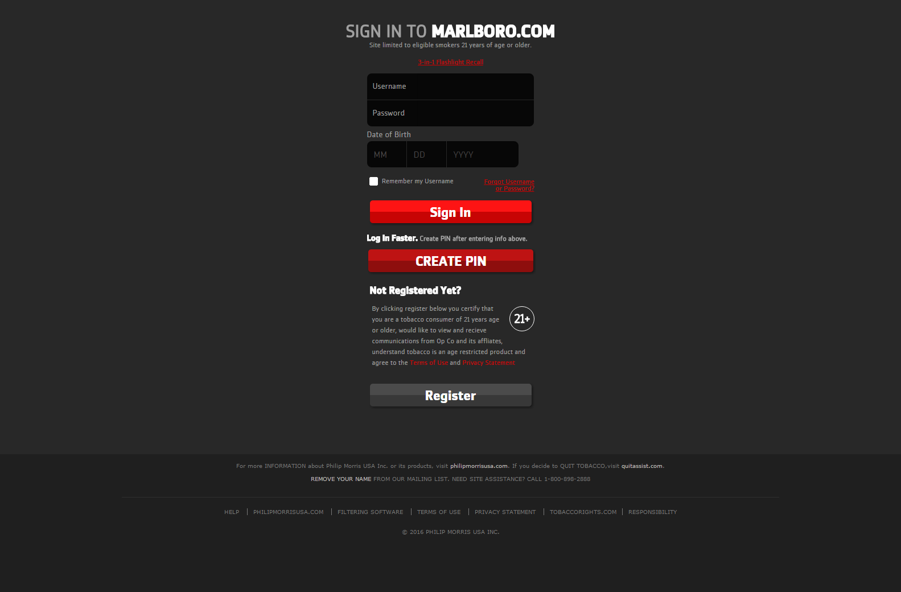

## Login Interrupts

We have changed the sequence of displaying login interrupts apart from sequence diagram or requirement documents based on Business aggrement. It is as follows

Verify Information🡪Temporary Password 🡪 Security Question interrupts.

## Registration

Additonally there were few changes that was requested to change the sign up flows.

## Remove the Tobacco Usage Questions from the “Verify Information” page and move it to the “Create Profile” Page

## Remove the “Email Address” field from the “Create Profile Page”

To accommodate the above changes, below are the new mockups that Capgemini team has put together:

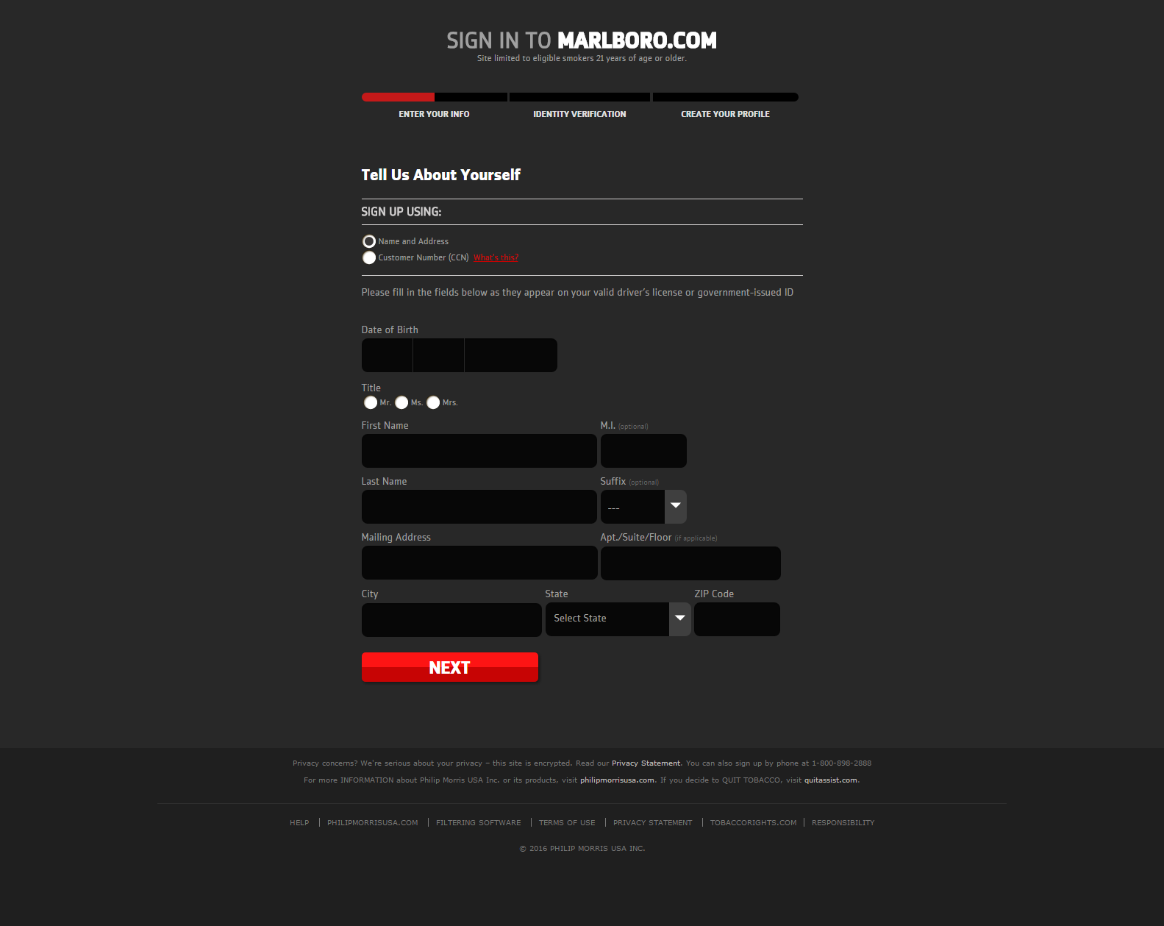

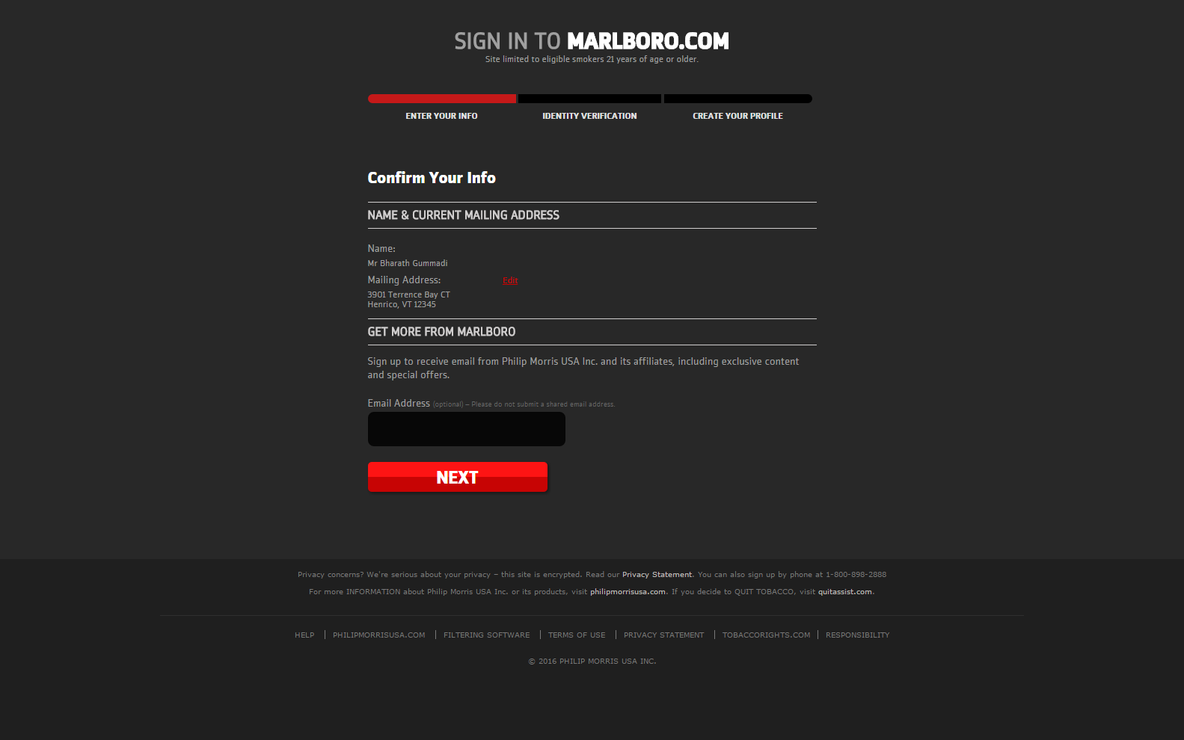

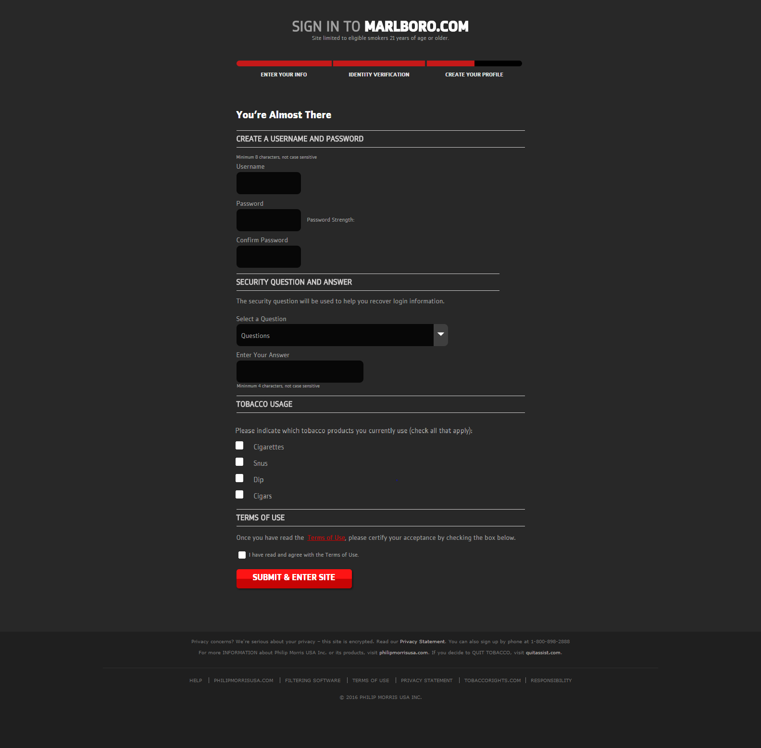

## Discovery and Ever Occupancy related changes are incorporated in to new Registration flow and functional details are mentioned in the SSN4 Additional Address Usecase specifications document.

## LexId changes: If the Lex Id is not returned with the New User Details and consumer not found with SFNA – Full search (status code:1363), then single Additional Address screen needs to be shown as discovery is failed with SFNA.

## If the the Lex Id is not returned with the New User Details and consumer is found with SFNA – Full search but house hold limit exceeds or opted off or DOB does not match (status code:1364), then New Registration flow should show error message screen with API message.

## Unsubscribe

Email unsubscribe implementation followed as per requirement documents but if user is subscribed at only opco level then as per requirement opco checkbox option on unsubscribe page whereas in existing site,it wont show only one opco check box rather it will redirect to “unsubscribe from promotional email page”.

## Edit Profile

## User can participate in survey on n number of times whereas existing site allows only once

## In the existing functionality For Marlboro Additional question comes in the survey without considering the user’s brand choice. We have changed that logic that If user select the competitor brand then  only additional question will come.

## SubMenu will not available in Edit Profile Page as per requirement with Back button user can redirect to branded websites.Existing Marlboro website doesn’t have this functionality

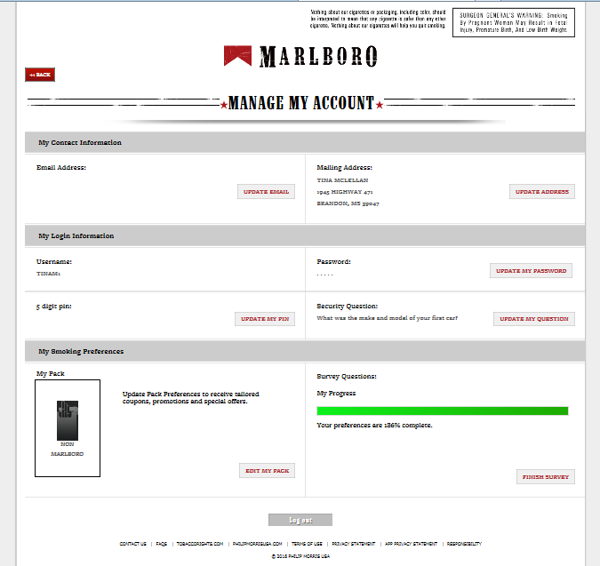

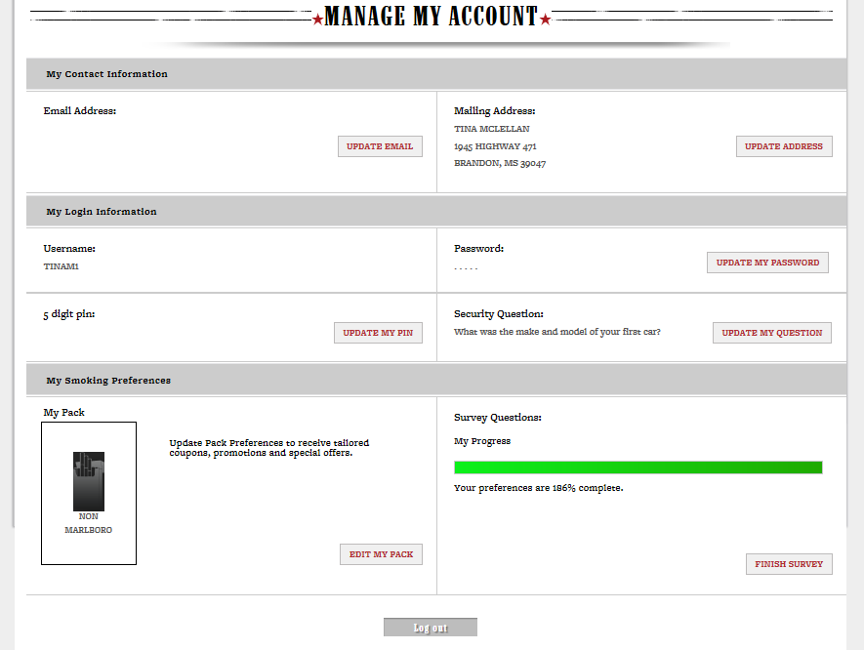

## Edit Profile Survey Question UI Requirements

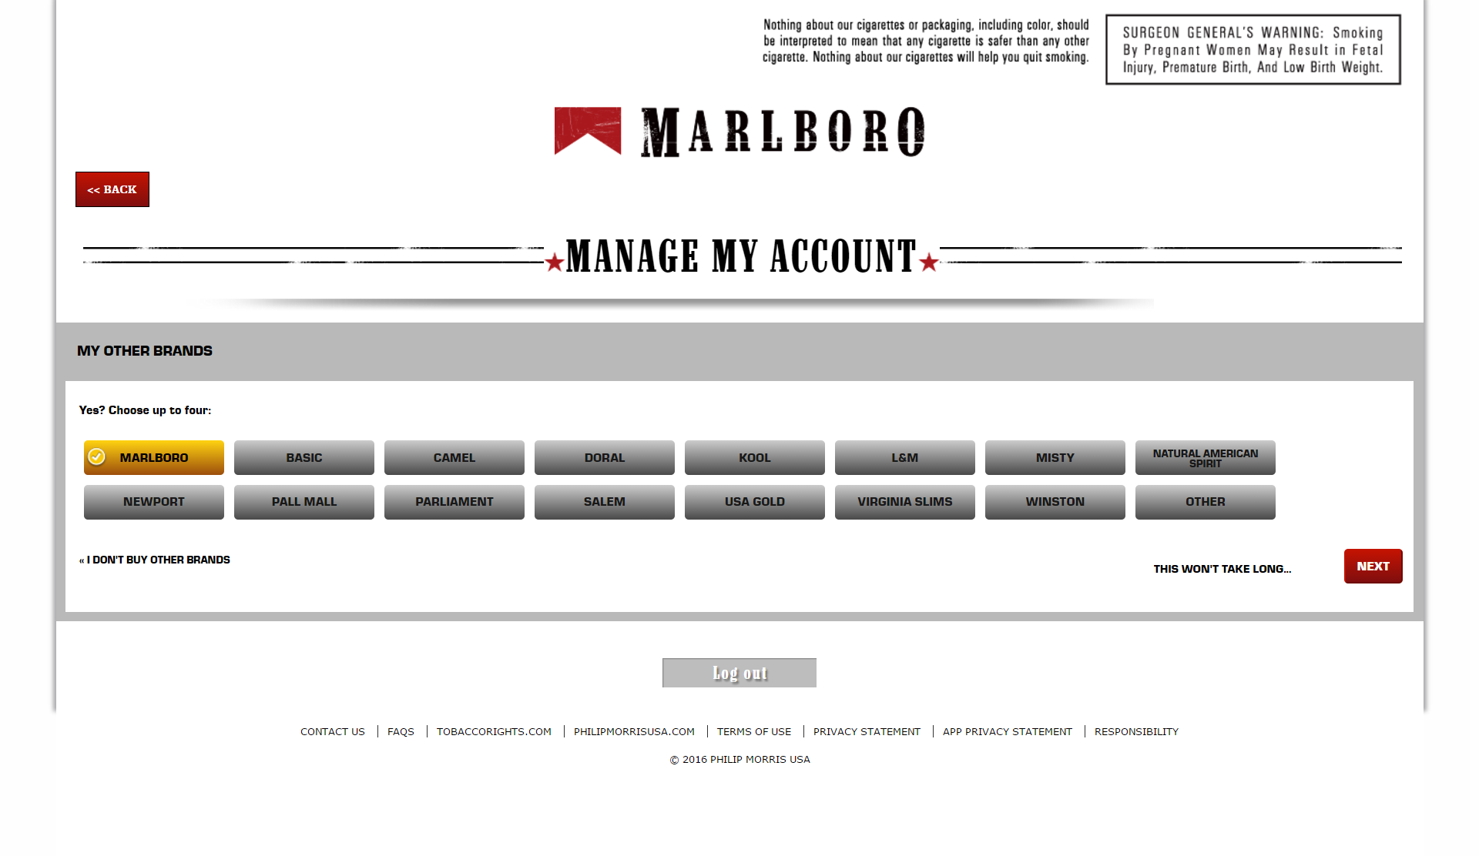

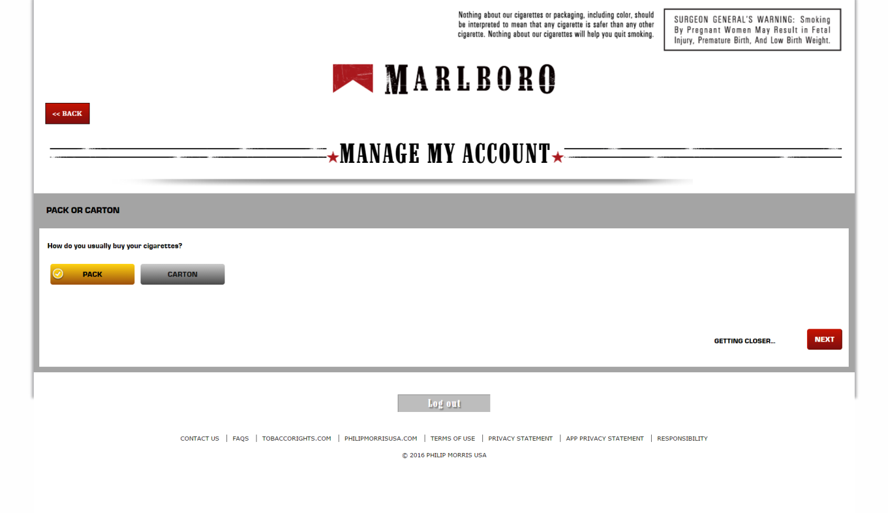

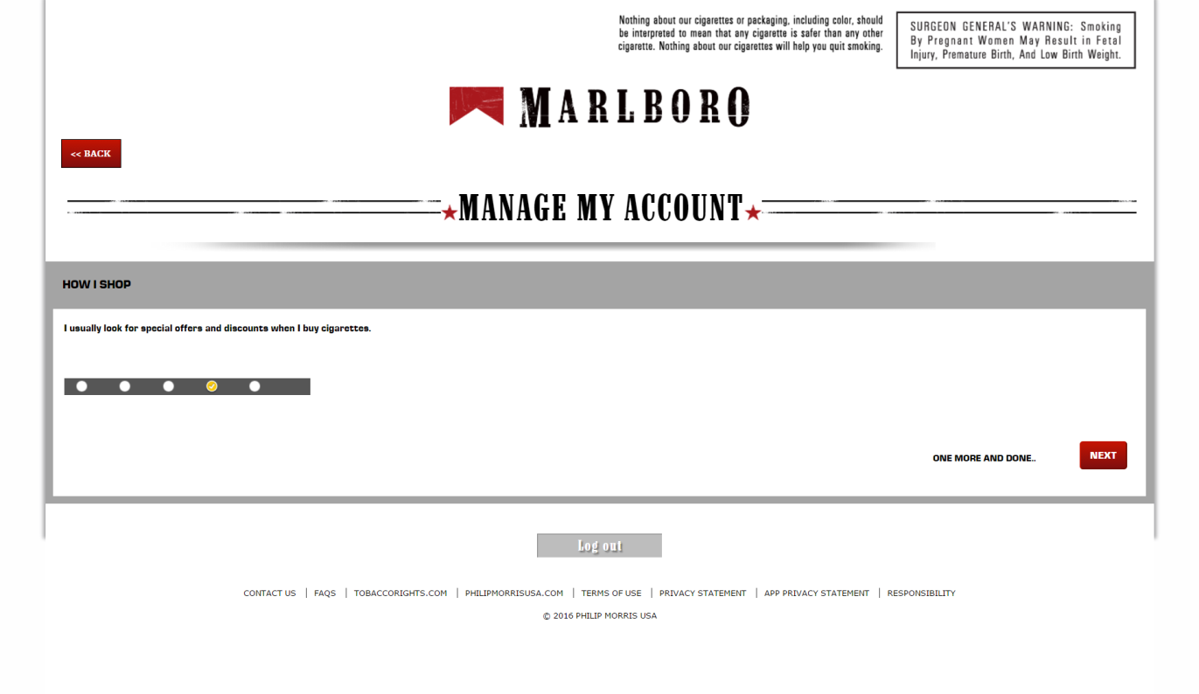

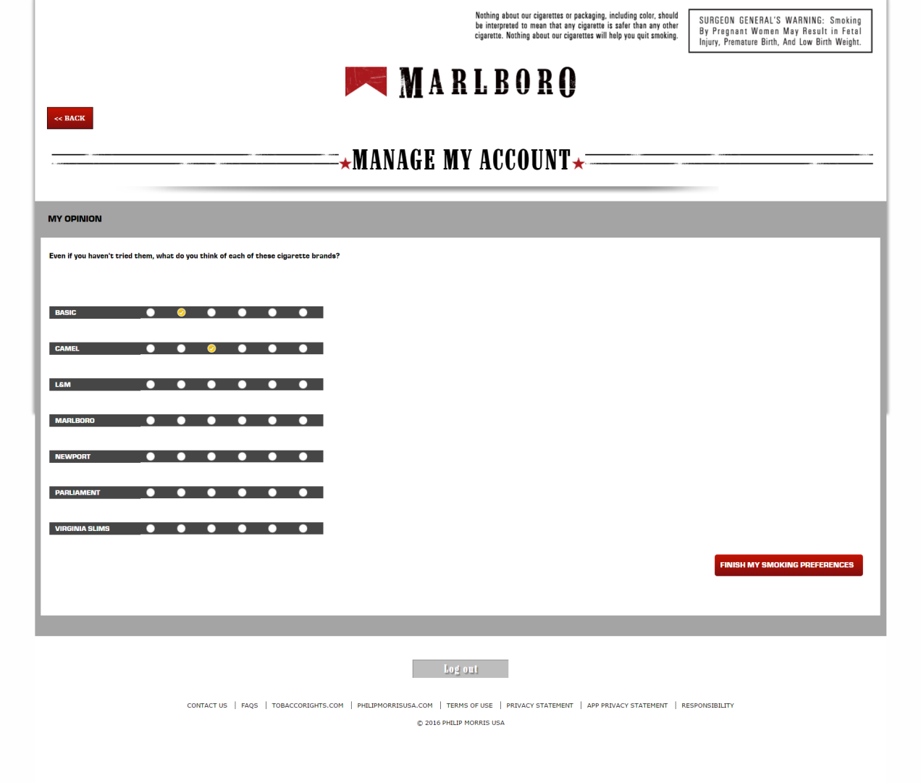

## Update Double Opt In

User clicks on the Email Double Opt In link and all the required validations are performed to update the Double Opt In. Once the Email Double Opt In is updated successfully, then Update Model Score needs to be triggered for the Marlboro Brand by Passing the corresponding CCN and Model Id (6024), irrespective of Update Model Score Status code, Double Opt In use case continues as it was earlier.

# Strategy

## Implementation & Supporting Information

Marlboro client will redirect to GConnect Application by prodiving Jwt in query string.Jwt will have return url.Once user is authenticated then User will redirect to return url along with new jwt token.

Detail implemenatation,control flow diagram and Handshake between Global Tobacco Connect platform and Marlboro.com provided in below document.

And also described the steps that needs to be considered for integrating the Global Tobacco Connect with its clients (e.g., Marlboro.com)



# System Interfaces

## Software Interfaces

Below framework,softwares are being used as part of Global Tobacco Connect application.

|  |  |  |
| --- | --- | --- |
| System Name | Type | Purpose |
| .Net Core 1.0 | Frameworek | ASP.NET Core is a new open-source and cross-platform framework for building modern cloud based internet connected applications, such as web apps, IoT apps and mobile backends. |
| MVC6 | Design pattern | The Model-View-Controller (MVC) is an architectural pattern that separates an application into three main logical components: the model, the view, and the controller |
| Azure db server | database | A SQL database native to the cloud, also known as a platform as a service (PaaS) database or a database as a service (DBaaS) that is optimized for software-as-a-service (SaaS) app development. It offers compatibility with most SQL Server features |
| Redis Cache | Data structure store | Redis is an open source (BSD licensed), in-memory **data structure store**, used as database, cache and message broker |
| Foundation | RWD framework | Foundation is a family of responsive front-end frameworks that make it easy to design beautiful responsive websites, apps and emails that look amazing on any device. Foundation is semantic, readable, flexible, and completely customizable. |
| Azure Server | Container | Microsoft **Azure** is an open, flexible, enterprise-grade cloud computing platform where code will be pushed. |
| Akamai Caching | Cache | Communication between Akamai and azure server,so that azure server application will be cache on Akamai server. |
|  |  |  |

# Appendix B: Glossary

| # | Term | Definition |
| --- | --- | --- |
|  | ATC21+ | Adult Tobacco Consumer 21 years of age or older |
|  | GTC | Global Tobacco Connect |
|  | Client Side | A client/server reference that implies “on the consumer’s local machine”. This can refer specifically to a browser or app |
|  | Server Side | A client/server reference that implies “not on the consumer’s local machine”. This typically will refer to the databases and web-services that make up the back-bone of “The System” |
|  | CCN | Consumer control number |
|  | Authenticated | A term for an ATC21+ that exists on the Adult Tobacco Consumer Database and has supplied information that proves they are the person they claim to be. This status can be achieved by interacting directly with a Brand Ambassador, completing their Double Opt In, registering via Global Connect, or interacting with a Live Op Customer Service Agent |
|  | Certified | ATC21+ has identified themselves as willing and eligible to receive Tobacco Communication from the Brand (as well as Parent Operating Company) that they are interested in |
|  | Qualified | ATC21+ is a combination of Age Verified, Authenticated and Certified for the Operating Company that owns the Brand they are interested in |
|  | Available | ATC21+ is both eligible and not opted off of any level of communication that the Brand falls under (this includes their Operating Company and Product Line, as well as their general status as a consumer) |
|  | Tobacco Usage | An Interrupt Survey that tracks the basic product preferences of an ATC21+. While the website ties this question to certification, it is not required for certification. |

REVISION HISTORY OF THE WORK PRODUCT

|  |  |  |  |  |  |
| --- | --- | --- | --- | --- | --- |
| # | Date | Version # | Section Changed | Details of changes made | Approved By |
| 1 | 03/10/2016 | V0.5 |  | Initial draft |  |
| 2 | 10/15/2016 |  |  |  |  |
| 3 | 12/20/2016 | V1.0 | 4.5.1 | Added the Edit profile Survey questions with new skins |  |